Neosha Allen
9/5/2026
Module 4.2 Assignment
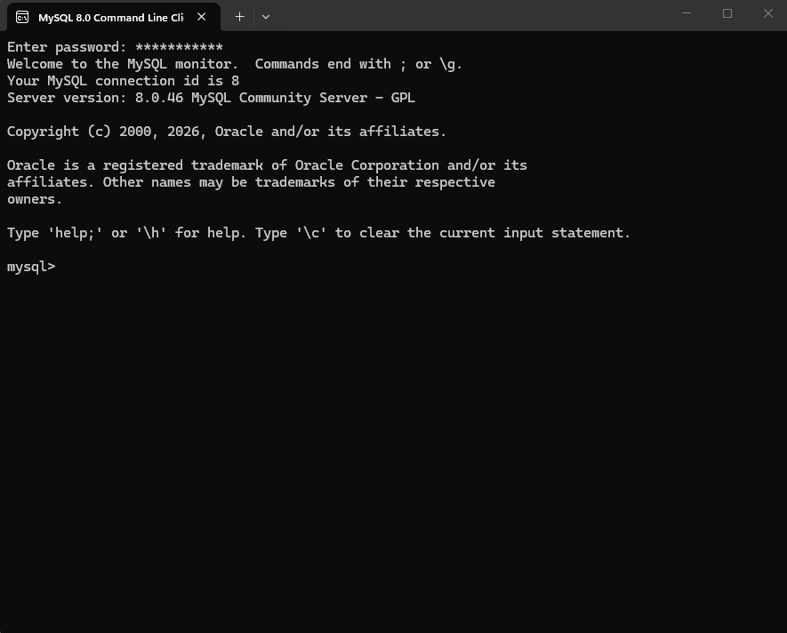

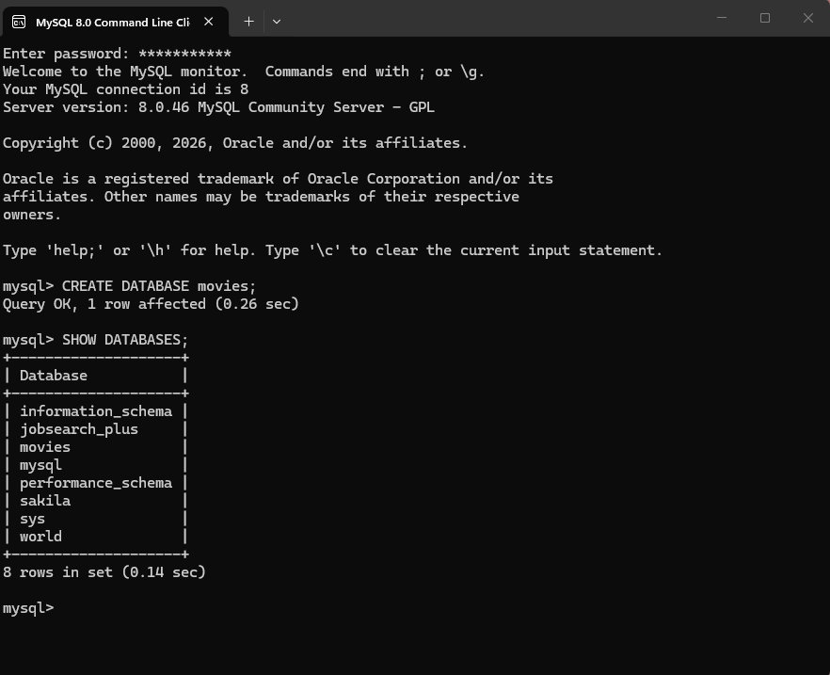

-- 3 functions to experiment with are:
UPPER(title), UPPER is used to convert the movie titles to uppercase letters.
LENGTH(title), LENGTH returns the number of characters in the movie titles name.
ROUND(rating, 0), ROUND is rounding the rating to the nearest integer.
-- Appropriate alias for the column headers would be:
AS Movie_Title_Uppercase
AS Title_Length
AS Rounded_Rating

RESULTS:
CREATE DATABASES movies;
USE movies;
CREATE TABLE movie_list; (
movie_id INT PRIMARY KEY AUTO_INCREMENT,
title VARCHAR(100) NOT NULL,
genre VARCHAR(50),
rating DECIMAL(3,1)
release_year INT );
INSERT INTO movie_list(title, genre, rating, release_year) VALUES
(‘Spider-Man: Bran New Day’, ‘Superhero’, 8.9, 2026 ),
(‘Captain America: Civil War’, ‘Action’, 7.8, 2016),
(‘Avengers: End Game’, ‘Sci-Fi’, 8.4, 2019);
SELECT
UPPER(title) AS Movie_Title_Uppercase,
LENGTH(title) AS Title_Length,
ROUND(rating, 0) AS Rounded_Rating
FROM movie_list;
